|  |
| --- |
| 1. Scroll to bottom of login screen |

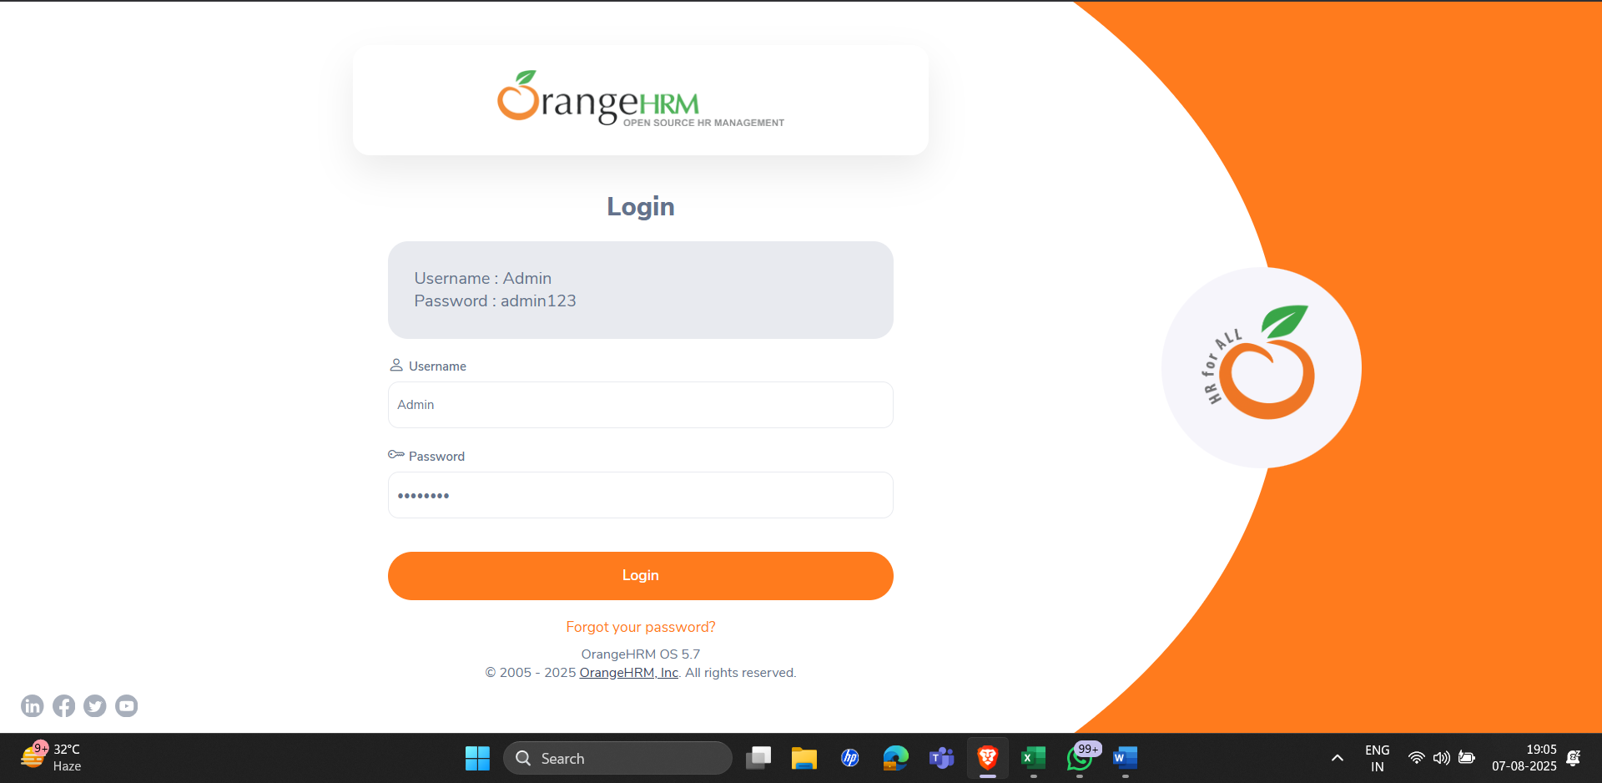

2. Click on the link

